**Portfolio Milestone: Final Research Paper**

Wendell Salas

Colorado State University Global

MIS 581: Capstone: Business Intelligence and Data Analytics

Dr. Jamia Mills

March 5, 2023

**Final Research Paper**

Property Tax Revenue Based Approach for Determining When to Plug and Abandon Low Production Oil and Gas Wells

**Abstract**

This study attempts to understand the relationship of Oil and Gas operations and suburban residential development as it pertains to property tax revenues. To accomplish this we combined datasets from the Boulder County Assessor’s office with those of the Colorado Oil and Gas Conservation Commission (COGCC) to help provide an understanding of the benefits of Oil & Gas operations with regard to property tax revenues versus the detrimental effect that Oil and Gas development has on offset residential property valuations. A method was developed that could be used to help determine when an Oil and Gas well no longer generates enough property tax revenue to offset its effect on residential property valuations and hence, property taxes derived from those homes.

Our method was able to determine when an Oil and Gas well no longer generated enough tax revenue to offset its effect on homes located within a 1 mile radius of the well’s location. We were also able to estimate what the total loss of tax revenue was for the County of Boulder, and what that could mean in terms of reduced funding for local schools. We hope that this method would bring a new tool that can be used to help local government decision makers make more informed decisions about when Oil and Gas wells should be considered for remediation.

**Introduction**

In areas of the country where Oil and Gas development is coming in contact with residential development there are measureable detrimental effects to property values due to the visual impacts of Oil and Gas activity (Stephens & Weinstein, 2019). Oil and Gas proponents are quick to mention the tax revenue benefits of Oil and Gas production and how those taxes go to fund local schools, infrastructure, and social programs. These benefits to local funding arising from Oil & Gas development have also been discussed in publications by Weber et al, 2016; Lee & Plummer, 2011; and Newell & Raimi, 2018. However, well production significantly declines over time and so too does the tax revenue from those wells. Oil & Gas Operators will develop field drilling and completion plans to try to grow their overall production, or at least keep producing at a steady level. However, all well production declines over time as the mineral resources are produced and the reservoirs are depleted. Consequently, there have been several Oil and Gas Operators that have gone bankrupt over time and have left the depleted wells that they once operated behind as Orphan Wells (Kang et al, 2021). In 2020 the State of Colorado had a backlog of 239 Orphan wells and 535 Orphan well sites (Press, 2021). In a study conducted by the EPA (2019) it was determined that there were about 2 million abandoned unplugged Oil and Gas wells throughout the United States. Some of these orphaned wells, that are no longer generating tax revenue, are continuing to be a cause of lower property tax revenues due to their proximity to residential developments.

**Objective**

The objective of this project will be to take residential assessed values from publicly available datasets and combine them with well location and property tax data to identify where Oil and Gas Operations are having the greatest impact on home values and to determine when the property taxes being assessed for a well no longer offset its effect on the residential properties that surround it.

**Overview of Study**

In the study by Stephens & Weinstein (2019) the authors discussed the give and take of natural resource development coinciding with residential development in the Front Range area of Colorado. In their research conclusion the authors made the following statement;

As shale development increases, policy makers may need to consider policies to address this substitution effect and to maintain or even improve upon the natural capital of these areas. Investing the immediate gains (through severance taxes or other fees) from oil and gas extraction into the natural capital of these areas may help ensure these amenity‐rich areas maintain their quality of life and continue to experience growth in the long term. Unfortunately, our analysis is unable to determine if this substitution effect is temporary or persistent. Future research should explore this to provide further guidance for policy making.

(Stephens & Weinstein, 2019, p. 1398, para. 2)

Our research hopes to lay the groundwork on helping to develop a process for quantitatively determining when the positive effects of Oil & Gas production no longer offsets the detriment that those activities bring to residential development, by comparing the effects to property tax revenues over time. This is the “substitution effect” that Stephens & Weinstein (2019) refer to in their study.

**Research Questions and Hypotheses**

This study will endeavor to answer the following question that will also help focus our work, and generate the following hypotheses that can be tested, with the data that is available, and help us answer the research question (RQ).

RQ: Can we develop a process to quantify if an Oil & Gas Well no longer generates enough property tax revenue to offset the detrimental effect the well has on residential property tax revenues for homes that are within one mile of the well’s location?

**Hypothesis**

Hypotheses are essential elements to any research. Where the research question helps to focus the research, the hypotheses are used to help explore and answer the research question. “The sole purpose of a hypothesis is to predict your paper's findings, data, and conclusion” (Deeptanshu & Dogra, 2022, para. 4). It takes into account what the dependent and independent variables are in the data that will be used to answer the research question. It then provides for an empirical method that can be used to verify the researcher’s assumptions of what the outcome will be. Javed (2021) states the function of the hypothesis in this way, “…the hypothesis serves to guide and delimit an investigation, giving a definitive direction to the search for the solution of a problem” (para. 1).

Below are the alternate (Ha) and null (Ho) hypotheses that will be explored to help this study answer the research question (RQ).

Ha – It can be determined when a well’s property tax revenue is no longer greater than the loss of residential property tax revenue associated with the well’s proximity to residential properties.

Ho – It cannot be determined when a well’s property tax revenue is no longer greater than the loss of residential property tax revenue associated with the well’s proximity to residential properties.

**Literature Review**

In the study by Stephens & Weinstein (2019) the authors came up with a process to determine what the effect on a home’s selling price would be due to individual factors, specifically around energy development and proximity to Oil and Gas wells and facilities. The authors determined that, “…the presence of any visible wells decreases house prices by about 0.8%” (Stephens & Weinstein, 2019, pg. 1397, para. 2). Additionally, they also stated that, “…each additional producing well within one mile is associated with a (0.1%) decrease in housing values” (Stephens & Weinstein, 2019, pg. 1397, para. 2).

The lion’s share of property tax revenue typically goes to local public education funding. Property taxes make up about one third of the total funding provided to public education (Allegretto et al, 2022; Lee & Plummer, 2011). It would be important to explore what the effect of Oil and Gas production is on local property tax revenues. Whether the effect is positive or negative may have much to do with where the well is in its production lifespan and how many homes are seeing reduced valuations because of their proximity to Oil & Gas wells.

Past studies on the impacts of Oil and Gas development on home values has mainly focused on the effects to the home’s sale price and on the detriments to scenic views, or concerns with water and air quality surrounding Oil and Gas development (Stephens & Weinstein, 2019; Boxall et al, 2005). One of the studies that were explored discussed a method for estimating the property value reduction by taking the price difference discovered in hedonic studies of the effects of Oil & Gas wells to property values and use them to build a gradient for tax revenue loss based on the distance of the home from the well (Morton et al, 2022, pg. 133, Estimating Loss of Property Tax Revenue). What is missing from past studies is a way to account for both the positive and negative effects of Oil and Gas development to overall local property tax revenue so that these impacts do not negatively affect local programs that are funded by property taxes.

**Research Design**

**Methodology**

This Study will use Boulder County Assessor data for the home value assessment and use this data to calculate the difference in property tax revenues for homes that are located close to Oil and Gas facilities versus similar homes that are not located near Oil and Gas facilities. This can be done by combining well location information with the residential location information. The well location information will be sourced from the public data files available at the Colorado Oil and Gas Conservation Commission (COGCC) website. The COGCC website can also provide individual well production over multiple years. The well’s production data can then be used to estimate what the property taxes contribution of each well would have been for each year. We will use yearly production information since tax assessments and collection is performed on a yearly basis.

This project is utilizing information from two main data sources; the Boulder County Assessor’s Office and the Colorado Oil & Gas Conservation Commission (COGCC). All information pertaining to home valuation, location, and tax revenue calculations derived from local mill levies will come from the Boulder County Assessor’s public databases. All information concerning Oil & Gas well production, and surface location data came from the COGCC’s public website.

**Boulder County Assessor’s Data**

The Assessor’s data will consist of the three different .csv data files listed below;

* Account_Parcels
* Owner_Address
* Values

These three separate datasets can be combined to produce a complete dataset that will contain all of the information needed to determine the property’s assessed value, and mill levy. Each property’s assessed value and mill levy will be used to calculate the estimated tax revenue. The Assessor’s data will also be combined with the Boulder County Geospatial Address_Points data to provide latitude and longitude coordinates for each property. It is important to add the geospatial data in order to help calculate distances between homes and well sites.

**Colorado Oil & Gas Conservation Commission (COGCC)**

The COGCC has a tremendous amount of public data available for download. There are several downloadable reports that summarize different aspects of Oil and Gas operations around the State of Colorado. The data that we are most interested in will be the individual well’s operational status for 2022 and the wellhead’s location information in the form of latitudinal and longitudinal coordinates for the County of Boulder. Our study will combine the assessed property tax data, for every well in Boulder County, for the year 2022 and wellhead location data from the Well Spots dataset. The Well Spots dataset also contains wellhead location data for non-producing wells.

**Methods**

This study will take into account the impact that visible wells have on home valuations. The variables that will be analyzed are property tax revenue loss for all of the homes within one mile of a well, property tax revenue per well, and number of wells within 1 mile of a residential property. The independent variable is the property tax revenue per well and the dependent variables will be the total property tax revenue loss associated with each well and number of homes within 1 mile for each Oil & Gas Well location.

In the study by Stephens & Weinstein (2019) the authors determined that, “…the presence of any visible wells decreases house prices by about 0.8%” (pg. 1397, para. 2). Additionally, the authors also stated that, “…each additional producing well within one mile is associated with a (0.1%) decrease in housing values” (Stephens & Weinstein, 2019, pg. 1397, para. 2). For this study we will use a cutoff distance of 1,000 feet to designate whether the well is visible to any nearby home and any additional homes that are located within 5,280 feet as contributing an additional 0.1% loss in property tax revenue per home.

Given that this study is working with quantitative data that has one independent variable and multiple dependent variables, the method of choice to help us test our hypotheses will be multiple linear regression. We can then use t-tests to test the significance level for each of the predictors by analyzing the slope for each predictor with the following hypotheses.

Ha – βn ≠ 0 (The slope is not equal to zero.)

Ho – βn = 0 (The slope is equal to zero.)

(Zach, 2021)

This study will make use of both the R programing language and the SAS on demand software. SAS will be used for most of the data exploration and characterization. R will be used for generating the calculated attributes. This would also include calculations for distances between latitudinal and longitudinal coordinates. There are specialized R libraries for performing calculations using latitude and longitude coordinates and there are great online sources for generating maps in R, as well. SAS would be the software of choice for performing the regression analysis on our dataset. We may also choose to perform these calculations for future home valuations or predicting well production decline curves. However, for the sake of time, we will utilize the research that has already been conducted on the percent reduction on home values as they pertain to proximity to Oil & Gas Facilities and Operations.

**Limitations**

One of the limitations to the Assessor’s data is that it is only for this year. We can ask the County for prior year’s home valuation information, and in most cases they would be able to provide it, but prior year assessment data is not readily available online. Also, trying to predict the future assessment values for home in Boulder County can be problematic with only a single year’s worth of assessed values. It is very likely that if we do this analysis again next year with that year’s current data, some of the results can change.

Regarding the limitation on the production data, it should be noted that some of these wells are producing into what are known in the Oil & Gas Industry as tank batteries. This means that multiple wells will be feeding oil into a single tank and the oil production is measured at the extraction side from the tank. Many times what operators do is just average the production from the tank battery across all of the wells that are producing into the tank. This is not the most accurate way of measuring exactly what is coming out of a single well that is tied into this sort of production distribution network. Another limitation to how we are going to determine the value of the produced oil and gas is with the price that the operator was able to get for their oil and gas. Many times these prices are based on contractual agreements and are not based on the average price of oil and gas at the time. We do not have a way of knowing what the exact price was that the Oil & Gas Company received for their product, we will be using the average market price for Oil & Gas to help us determine what the property tax assessment could have been, but we will not be working with the exact price.

It is important to understand that yearly variations in property values and Oil & Gas prices can change the results of this analysis from year to year. This process should not be used as the final determination of when an Oil & Gas well should be plugged and abandoned, but used to help local officials and operators identify certain wells that should be included in that discussion.

**Ethical Considerations**

While all of the data being used in this study came from open public sources, there is still a need to handle and present it in an ethical manner. While this study uses a very limited set of variables that come from both the Assessor’s and COGCC’s website, the data downloads contain a tremendous amount of additional data. These additional attributes contain information that can identify a specific owner, business, or Oil & Gas Operator. Care should be taken to display the data in aggregate and not point out any one specific property, owner, well location, or operator.

**Findings**

To begin our analysis we took the raw data from both the Assessor and the COGCC and performed some quick data cleanup. We knew that the Assessor’s data set would have information on commercial and tax exempt properties. Since we are not interested in those, we filtered them out of the analysis dataset before beginning our data exploration. The COGCC’s Well production data needed to be combined with the Well Spot data that has the well location information. Once that was done, we then focused on removing Wells with a Well Status of PA. PA is the designation of Plugged and Abandoned wells. However, we did not simply remove all of the wells with a PA designation. This is due to some PA locations still generating property taxes through the assessment of Business Personal Property that is still on the location. While the well is no longer producing, there is still surface equipment on the location that is being utilized for other Oil & Gas operations. That equipment is still generating property taxes, and it’s also still effecting nearby home values due to their proximity to residential development. We only removed the Wells that had a status of PA and zero values for assessed property taxes. That combination would determine which wells and locations had been plugged and abandoned with all surface equipment removed and the site remediated.

Once this first step in data cleanup was completed we then explored the two datasets to help us identify other anomalies and potential outliers that would probably need to be removed. See Table 1 for a look at the frequencies for each of the different well statuses.

**Table 1**

*Frequencies for the Different Well Status Designations*

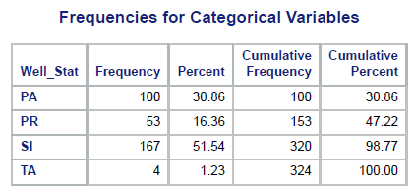

Table 1 Legend:

* PA – Plugged & Abandoned Well
* PR – Producing Well
* SI – Shut-in Well
* TA – Temporarily Abandoned Well

The wells that we are most concerned about are the ones designated with PA and SI, these wells will have the lower property tax assessments and they also make up the majority of wells in the area of our study.

Once the exploration and clean-up of the datasets was completed, we moved on to identifying the homes that were located within the circle of influence for each well. The circle of influence consists of the number of homes that are within 1,000 ft. and 1 mile from each well. For our purposes, we are considering any home within 1,000 ft. of the well as being within sight of the well, and any home within 1 Mile as having its home value affected by nearby Oil & Gas development. Based on Stephens & Weinstein’s (2019) work, homes that had a well site within view showed a loss of 0.8% of value and homes that were within one mile of a well site showed value losses of 0.1% for every well located within that one mile. Since we are looking at how a single well affects the valuation of homes within its circle of influence we will be stating that for each home within one mile of a well’s location that the home’s value is reduced by 0.1%. Later on we will use these counts, along with the total property tax revenue for the homes within these circles of influence, to calculate the total effect on property tax revenue for each well that is located near a residential development, see Image 1 for a visual representation of our calculations.

**Image 1**

*Google Earth Image Showing Well Locations, Homes, 1000 ft Circle, and 1 Mile Circle around Two Wells Near Housing Developments*

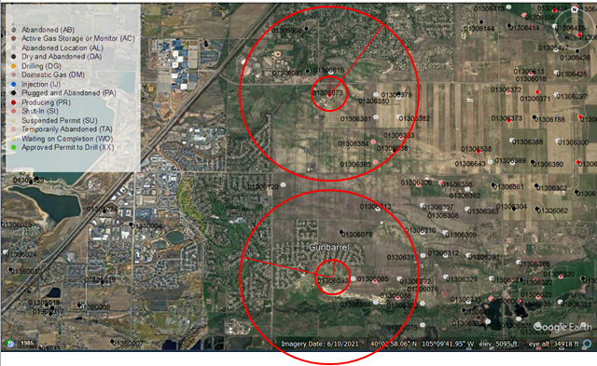

*Note:* Adapted from *COGCC’s Well Spot Google Earth Map*, by Colorado Oil & Gas Commission, 2023, COGCC Downloads Portal. https://cogcc.state.co.us/data2.html#/downloads

In Image 1, the smaller circle designates the 1,000 ft. perimeter where the well can be within sight of a residential property. The larger circle is the 1 mile circle of influence that encompasses the residential properties that will see some amount of value degradation due to local Oil & Gas activity.

To calculate the distances between each well in the Well dataset and all of the residential properties in the Assessor dataset, we combine a stacked for-loop script with the *rdist.earth()* function from the **fields** package in the R programing language. Any home that was further away from a well than 1 mile is excluded and any home within the 1 mile circle of influence is counted and their assessed property tax is summed up. We also tally up any home that is within the 1,000 ft. circle of influence. These properties will see the higher 0.8% degradation to their property values, while the other homes within the 1 Mile circle of influence will see the lower 0.1% degradation to their property values (Stephens & Weinstein, 2019). See Table 4 for a small example of the output from the R script.

**Table 4**

*R Script Output File*



We then took the output from the R script and did some additional calculations to start building the information for what the average property tax was for each home associated with a specific well. We built a couple of Boolean attributes that would indicate if a specific well had homes located within the 1,000 ft. circle of influence and whether the calculates showed that a specific well should be considered for plugging and abandoning and the site reclaimed. We also calculated what the effect of each well was to the overall property taxes collected from the homes within the well’s 1 mile circle of influence and combined that with the values for the homes within the wells 1,000 ft. circle of influence. Once the total effect of the well’s influence on residential property values was calculated, we then subtracted the influence value from the specific well’s total property tax. If the value was still positive, then the well generated more property tax revenue then it affected by its proximity to residential homes. If the value was negative, then the well’s property tax revenue was not enough to offset its effect on nearby homes. Those wells with negative values in this field would be the ones slated for review. Table 5 shows the results of the output from these calculations.

**Table 5**

*Results from the Circle of Influence Calculations for Each Well*



The output from the R program, that includes the additional calculations which describe the wells influence on property values for surrounding residential properties, will be used to help develop a linear regression model.

We did check to see if our data was normally distributed before attempting to use it in a linear regression model. However, as it turns out, most was not normally distributed. We attempted to fix this issue by apply a natural log transform on the data, this did help one of the variables, but normality issues still persisted. We looked at using other transforms, but they were also not able to normalize our data. We decided on using the log transformed data to see what results we would get on our Multiple-Linear Regression (MLR) model with Stepwise selection; see Figure 3, Figure 4, Figure 5, and Figure 6 for the model results.

**Figure 3**

*Results of the Fit Criteria for the Multiple-Linear Regression Model*

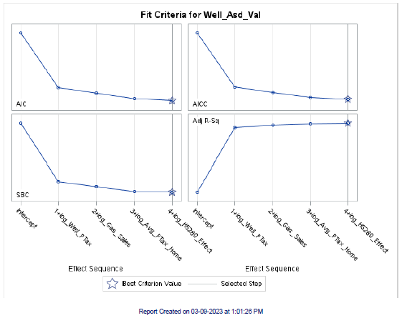

Out of the 16 parameters that were used in the MLR model only four met the significance value to be utilized in building the final model.

**Figure 4**

*Results of the Parameter Estimates for the Multiple-Linear Regression Model*

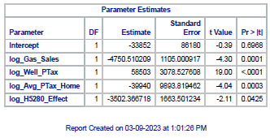

The parameter estimates show that, while the four parameters that make up the final model have p-values that met our criteria, the standard errors are quite large.

**Figure 5**

*Results of the Fit Diagnostics for the Multiple-Linear Regression Model*

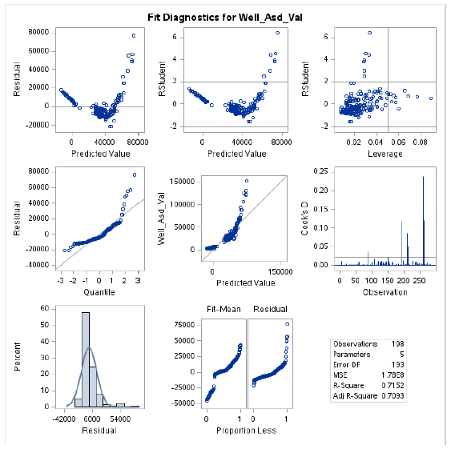

As we can see from the Fit Diagnostics, our data still suffers from non-normal distribution. This is backed up in Figure 6 where we look at the Residuals.

**Figure 6**

*Results of the Residual Analysis for the Multiple-Linear Regression Model*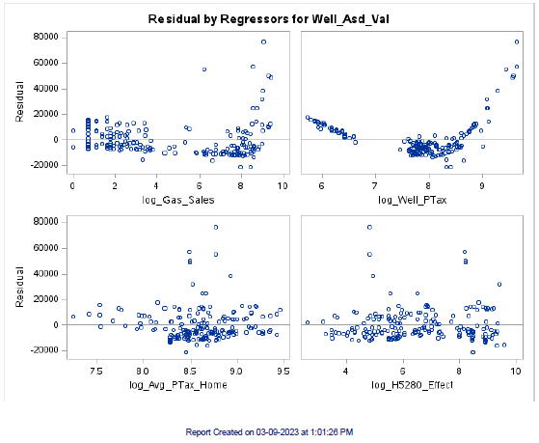

We can see from the Residuals the non-normal distribution of the log_Well_PTax variable and that the other variables show signs of potential outliers that will need further scrutiny to see if they can be removed from the analysis.

**Conclusion**

This study explored the effects of Oil & Gas operations occurring near residential urban development and its implications on property tax revenue. From our literature review we found many works on the effects of Oil & Gas development on residential home prices and we have found works on the effects of Oil & Gas tax revenue on local government funding. This study attempted to bridge the gap between these two, sometimes adversarial activities, by looking at how they affect the local funding that helps municipalities build better communities.

This analysis combined data from the Boulder County Assessor’s database and the State agency that oversees Oil & Gas development for the State of Colorado in an attempt to help determine when an Oil & Gas well or wells no longer produce enough minerals to offset the loss in property tax revenue from the homes that are affected by their proximity. While the MLR model did not produce the results that we had hoped, due to the large standard error, we were able to develop the beginnings of a method that could be used to calculate when an Oil & Gas Well may need to be considered for remediation.

The results from the R output showed that our analysis was able to identify that out of the 285 wells in our study 123 of them were generating insufficient property tax revenue to offset their effect on local residential property taxes, using the criteria from Stephens & Weinstein (2019). It also showed that, overall, the total effect on property taxes, for Boulder County, was negative. This meant that the wells, in total, did not produce enough property tax revenue to offset their effect on the residential properties that lay within one mile of a well location. While there were 162 wells that were generating more tax revenue than they affected, the ones that were not have a much greater negative effect. Our analysis calculated a property tax revenue loss, from wells that did not generate enough property taxes to offset their effect, of $535,784. Given that slightly over 50% of all property taxes go to fun public education, this would equate to a loss in revenue of around $267,892 for public schools in the Boulder County school districts.

**Recommendations**

Our study indicates that there may be a need to include multiple year analysis to be able to better develop trends and be able to more effectively predict when Oil & Gas wells may be nearing the end of their productive lifespan based on property tax revenue generation. The analysis would also benefit from further exploration of ways to normalize the data collected and generated for this study, or the use of a different model for the analysis that does not require normalized data.

**References**

Allegretto, S., Garcia, E., & Weiss, E. (2022, July 12). *Public education funding in the U.S. needs an overhaul: How a larger federal role would boost equity and shield children from disinvestment during downturns*. Economic Policy Institute. <https://www.epi.org/publication/public-education-funding-in-the-us-needs-an-overhaul/#:~:text=Education%20%EE%80%80funding%EE%80%81%20generally%20is%20inadequate%20and%20inequitable%3B%20It>

Boulder County Assessor. (2023). Assessor’s Property Data Download. <https://bouldercounty.gov/property-and-land/assessor/data-download/>

Boulder County Geospatial Open Data. (2023). Address Points. <https://opendata-bouldercounty.hub.arcgis.com/datasets/bouldercounty::address-points/about>

Boxall, P. C., Chan, W. H., & McMillan, M. L. (2005). The impact of oil and natural gas facilities on rural residential property values: a spatial hedonic analysis. *Resource and Energy Economics*, *27*(3), 248–269. <https://doi.org/10.1016/j.reseneeco.2004.11.003>

Colorado Oil & Gas Commission. (2023a). Well Surface Location Data. COGCC Downloads Portal. <https://cogcc.state.co.us/data2.html#/downloads>

Colorado Oil & Gas Commission. (2023b). Yearly Well Production for Boulder County. COGCC COGIS Database. <https://cogcc.state.co.us/data.html#/cogis>

Deeptanshu D, & Dogra, S. (2022, September 26). *Research Hypothesis: Definition, Types, Examples and Quick Tips*. Typeset Resources. <https://typeset.io/resources/how-to-write-research-hypothesis-definition-types-examples-and-quick-tips/>

EPA. (2019, April 11). *Inventory of U.S. Greenhouse Gas Emissions and Sinks | US EPA*. US EPA. <https://www.epa.gov/ghgemissions/inventory-us-greenhouse-gas-emissions-and-sinks>

Javed, A. (2021, July 7). *Importance of hypothesis in research*. EngloPedia. <https://englopedia.com/importance-of-hypothesis-in-research/>

Kang, M., Brandt, A. R., Zhong Zheng, Boutot, J., Chantel Yung, Peltz, A. S., & Jackson, R. B. (2021). Orphaned oil and gas well stimulus-Maximizing economic and environmental benefits. *Elementa: Science of the Anthropocene*, *9*, 1–13. <https://doi.org/10.1525/elementa.2020.20.00161>

Lee, T., & Plummer, E. (2011). Valuation of Oil and Gas Properties and Their Contribution to School District Tax Revenues Evidence from Texas. *Journal of Property Tax Assessment & Administration*, *8*(3), 5–17.

Morton, P., Kerkvliet, J., & Hjerpe, E. (2022). Impact Fees, Bonding Reform, and Oil and Gas Development. *Colorado Natural Resources, Energy & Environmental Law Review*, *33*(1), 103–151.

Newell, R.G., & Raimi, D. (2018). The fiscal impacts of increased U.S. oil and gas development on local governments. *Energy Policy*. Vol. 117, ppg. 14-24. <https://doi.org/10.1016/j.enpol.2018.02.042>

Press, T. A. (2021, April 1). *Joe Biden’s plan would spend $16B to clean up old mines and oil wells and support jobs to do it*. The Colorado Sun. <https://coloradosun.com/2021/04/01/orphan-wells-clean-up-colorado-biden-bennet/>

Stephens, H. M., & Weinstein, A. L. (2019). Household valuation of energy development in amenity‐rich regions. *Growth & Change*, *50*(4), 1375–1410. <https://doi.org/10.1111/grow.12335>

Weber, J. G., Burnett, J. W., & Xiarchos, I. M. (2016). Broadening Benefits from Natural Resource Extraction: Housing Values and Taxation of Natural Gas Wells as Property. *Journal of Policy Analysis & Management*, *35*(3), 587–614. <https://doi.org/10.1002/pam.21911>

Zach. (2021, October 4). *Understanding the t-Test in Linear Regression*. Statology. <https://www.statology.org/t-test-linear-regression/>